**Step 1: Acquiring SafeGraph POI Data from the Snowflake Marketplace**

* Log into your Snowflake account and set the role to the ACCOUNTADMIN role
* Click → Home Icon
* Click → Data Products → Marketplace
* Search → frostbyte
* Click → SafeGraph: frostbyte
* Under Options dropdown
  + Rename Database → FROSTBYTE_SAFEGRAPH (all capital letters)
  + Grant to Additional Roles → PUBLIC
* Click → Get
* This will create a logical database from the marketplace data share listing

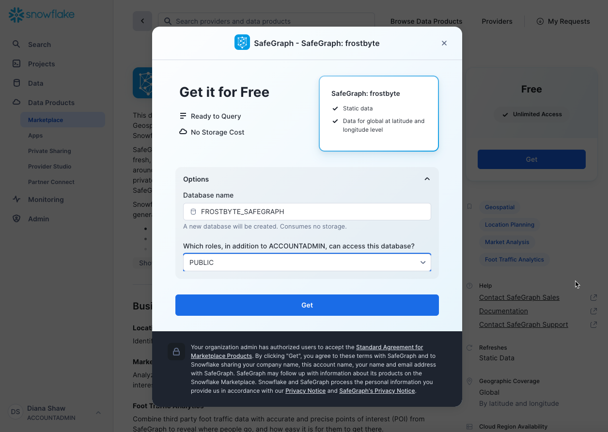

**Step 2: Create Sandbox HOL Database and Load Sales Data to Tables**

* Run the script Snowpark_HOL_Setup_Data
  + Creates a new database named HOL
  + Creates table in the PUBLIC schema named shift_sales and view shift_sales_v
  + Loads data to shift_sales from public S3 bucket
  + Creates table in the PUBLIC schema named sales and view sales_forecast_input
  + Loads data to sales from public S3 bucket

**Step 3: Create Sandbox Schema, Role, Warehouse, User for each HOL user**

* Run the script Snowpark_HOL_Setup_Users
  + Creates utility db
  + Creates stored procedure to execute sql x times based on # of users
  + Creates a schema, role, warehouse and user such as Schema1, Role1, WH1, User1 for each HOL user
  + Clones tables & views with sales data from HOL.PUBLIC schema to each user’s schema
  + Grants the necessary privileges to each user for their Sandbox Schema